Bampton and District Local History Society members’ meetings
Vicars of Askham:
unexpected, quirky, tragic, curious….and shocking
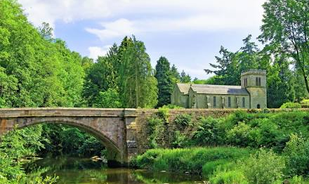
Sarah Banks

Tuesday 4th February 2025
7:30pm
Bampton Memorial Hall
Everyone welcome!
Home-baked refreshments will be served
Members £1 Visitors £3

